OOP EXPERIMENT-5

NAME-ANMOL
SAP-590011794
BATCH-20
DATE-25 FEB 2026

SUBMITTED TO- PROF. Kalluri Shareef Babu

Theory

Method Overloading
Same method name is defined with different parameter lists (different number, type, or order of arguments).
Compile-time polymorphism is demonstrated through overloaded methods like:
calculate( ), area( ), volume( ), display( ).
Overload resolution is done by the compiler based on method signature.

Constructor Overloading
Multiple constructors in the same class initialize objects in different ways.
Default constructor initializes with default values.
Parameterized constructor initializes with user-provided values.
Demonstrated in classes like Employee andStudent style programs.

Constructor Chaining
this() is used inside one constructor to call another constructor of the same class.
Helps avoid duplicate initialization logic.
Must be the first statement in the constructor.

Default Constructor Concept
If no constructor is written, Java provides a default no-argument constructor.
Instance variables receive default values (e.g., int -> 0, reference -> null).
Once a custom constructor is defined, implicit default constructor is not provided.

Static Variables
static variables belong to the class, not individual objects.
Shared memory: all objects see the same static value.
Updates from one object are reflected for all objects.
Used for class-level counters like total object count.

Instance Variables
Instance variables belong to each object separately.
Each object keeps its own copy of instance state.
Changing one object's instance fields does not change another object's fields.

Static Methods and Access Rules
static methods are callable using class name.
A static method cannot directly access non-static (instance) members.
Reason: static context has no this reference to a specific object.

Blocks and Execution Order
static block executes once when class is loaded.
instance block executes each time an object is created, before constructor body.
constructor executes after instance block during object creation.
main() starts program execution.

Method Call Ambiguity in Overloading
Ambiguity occurs when compiler finds multiple overloaded methods equally suitable.
Example case: argument list that can match two methods via numeric conversion.
Resolved by explicit casting or using clearly typed arguments.

‘this’ Keyword
this.variable distinguishes instance field from parameter with same name.
this( ) invokes another constructor in same class.

Input Handling Used
Scanner (nextInt, nextDouble) for numeric keyboard input.
BufferedReader + InputStreamReader with readLine() for text input.
Integer.parseInt() converts string input to int.

Math Utility Functions
Math.sqrt() is used in geometric area computation.
Formula-based calculations are implemented through methods.

Output Functions
System.out.print() and System.out.println() are used for formatted console output.
Values are displayed from object methods and main() to show behavior.

Object Creation and Method Invocation
Objects are created using new.
Instance methods are called through object references.
Static members are accessed using class name or object reference

Exe5_1
//Write a Java program that overloads a method calculate() to perform:
//- Sum of two integers
//- Sum of three integers
//- Sum of two double values
//- Concatenation of two strings
//Display the result of each method call from main().

class Overload
{
void calculate(int a,int b)
{
System.out.println("Sum of two integers: "+(a+b));
}
void calculate(int a,int b,int c)
{
System.out.println("Sum of three integers: "+(a+b+c));
}
void calculate(double a, double b)
{
System.out.println("Sum of two double values: " +(a+b));
}
void calculate(String str1, String str2)
{
System.out.println("Concatenation of two strings: "+str1+str2);
}
}

public class exe5_1
{
public static void main(String args[])
{
Overload obj=new Overload();
obj.calculate(17,19);
obj.calculate(5,7,11);
obj.calculate(2.96,5.67);
obj.calculate("hell","o");
}
}
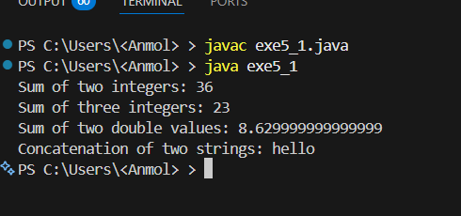
Observation: The program demonstrates the use of overloaded methods to perform various arithmetic operations and string concatenation on different data types.

Exe5_2
// Create a class Employee with instance variables: name, id, salary.
// - Default constructor initializes with fixed values.
// - Parameterized constructor initializes with user-provided values.
// Create two objects and display employee details.
class employee
{
String name;
int id,salary;
employee()
{
name="Rahul";
id=590014725;
salary=80000;
}
employee(String name,int id,int salary)
{
this.name=name;
this.id=id;
this.salary=salary;
}
void display()
{
System.out.println("Employee Name: "+name);
System.out.println("Employee ID: "+id);
System.out.println("Employee Salary: "+salary);
}
}
public class exe5_2
{
public static void main(String args[])
{
employee e1=new employee();
employee e2=new employee("Anmol Thapliyal",590011794,85000);
e1.display();
e2.display();
}
}
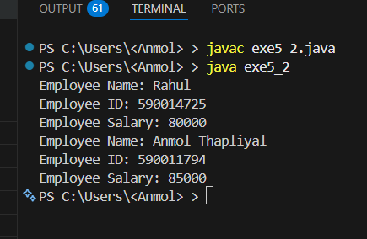
Observation: The program demonstrates the use of constructors to initialize object properties and display employee details using a method.

Exe5_3
// Create a class Counter with:
// - static variable count
// - instance variable id
// Increment both variables inside constructor.
// Create 3 objects and display values of count and id for each object.
// Explain the output.
class Counter
{
static int count;
int id;
Counter()
{
count++;
id=count;
}
}
public class exe5_3
{
public static void main(String args[])
{
Counter c1=new Counter();
Counter c2=new Counter();
Counter c3=new Counter();
System.out.println("Counter 1: count="+Counter.count+", id="+c1.id);
System.out.println("Counter 2: count="+Counter.count+", id="+c2.id);
System.out.println("Counter 3: count="+Counter.count+", id="+c3.id);
}
}
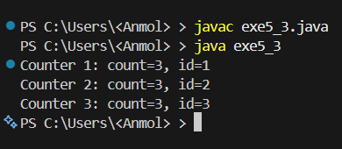

Observation: The static variable 'count' is shared among all instances of the Counter class, so it increments with each new object created. The instance variable 'id' is unique to each object and is assigned the current value of 'count' at the time of object creation. Therefore, all objects will have the same 'count' value, but different 'id' values corresponding to their creation order.

Exe5_4
// Create a class that has one instance variable and one static variable.
// Create a static method trying to access both variables.
// Observe and fix the compilation error.
// Explain why static methods cannot access instance variables.
class issta
{
int a;
static int b;
static void display()
{
//System.out.println("Instance variable a = "+a); // This line would cause a compilation error
System.out.println("Static variable b="+b);

}
void view()
{
System.out.println("Instance variable a="+a);
System.out.println("Static variable b="+b);
}
}
public class exe5_4
{
public static void main(String args[])
{
issta.display();
issta obj=new issta();
obj.view();
}
}
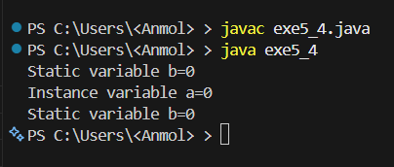
Observation: Static methods cannot access instance variables because they belong to the class rather than any specific instance. Instance variables require an object of the class to be accessed, while static methods can be called without creating an object. Therefore, static methods can only directly access static variables and cannot reference instance variables without an object.

Exe5_5
// Write a program containing:
// - Static block
// - Instance block
// - Constructor
// - main() method
// Print statements in each block and observe execution order.
class exe5_5
{
static
{
System.out.println("This is a static block.");
}
{
System.out.println("This is an instance block.");
}
exe5_5()
{
System.out.println("This is a constructor.");
}
public static void main(String args[])
{
exe5_5 obj=new exe5_5();
System.out.println("This is the main method.");
}
}
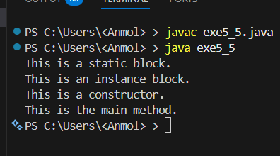
Observation: The execution order is as follows: First, the static block is executed when the class is loaded. Then, when an object of the class is created, the instance block is executed followed by the constructor. Finally, the main method is executed. Therefore, the output will be:

Exe5_6
// Write a program with:
// void display(int a, float b)
// void display(float a, int b)
// Call display(10, 10);
// Does it compile? Explain why ambiguity occurs.
class Ambiguity
{
void display(int a,float b)
{
System.out.println("Method with int and float parameters called: "+a+", "+b);
}
void display(float a,int b)
{
System.out.println("Method with float and int parameters called: "+a+", "+b);
}
}
public class exe5_6
{
public static void main(String args[])
{ Ambiguity obj=new Ambiguity();
//obj.display(10, 10); // This line will cause a compilation error due to ambiguity
obj.display(10.6f,10);
obj.display(10,10.8f);
System.out.println("The call obj.display(10, 10) is ambiguous because both methods can be called with the given arguments. The compiler cannot determine which method to call since both methods can accept the arguments (10 can be treated as an int or a float). To resolve this ambiguity, you can either cast the arguments to the desired types or provide different argument values that clearly match one of the method signatures.");
}
}
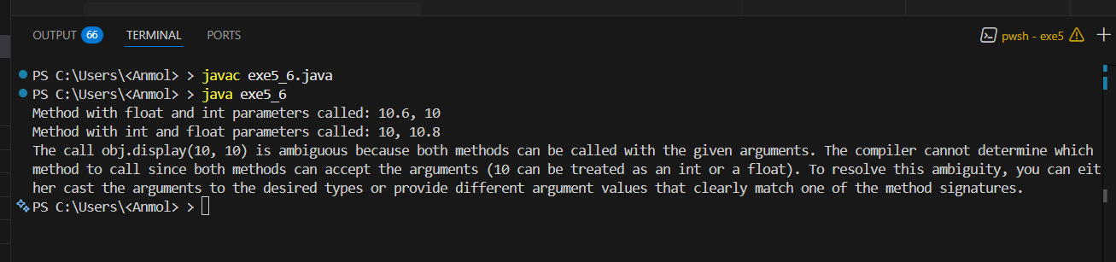
Observation: The call obj.display(10, 10) is ambiguous because both methods can be called with the given arguments. The compiler cannot determine which method to call since both methods can accept the arguments (10 can be treated as an int or a float). To resolve this ambiguity, you can either cast the arguments to the desired types or provide different argument values that clearly match one of the method signatures.

Exe5_7
// Create a class with two instance variables and one static variable.
// Modify all variables from main() using object reference.
// Create two objects and observe the changes.
// Explain why static variable changes affect all objects
class ex
{
int v1;
int v2;
static int sv;
void modify(int var1,int var2,int stvar)
{
v1=var1;
v2=var2;
sv=stvar;
}
void display()
{
System.out.println("Instance Variable 1: "+v1);
System.out.println("Instance Variable 2: "+v2);
System.out.println("Static Variable: "+sv);
}
}
public class exe5_7
{
public static void main(String args[])
{
ex obj1=new ex();
ex obj2=new ex();
obj1.modify(3,7,17);
obj2.modify(96,25,19);
System.out.println("Object 1:");
obj1.display();
System.out.println("Object 2:");
obj2.display();
}
}
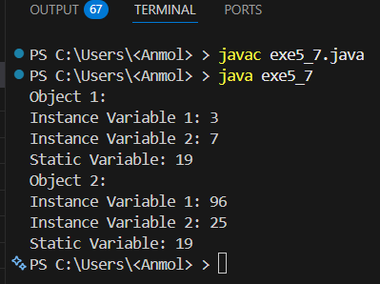
Observation: The static variable 'sv' is shared among all instances of the class 'ex'. When we modify 'sv' using one object (obj1), it changes for all objects of the class, including obj2. This is because static variables belong to the class rather than any specific instance, so they are shared across all instances. Therefore, when obj2 modifies 'sv', it overwrites the value set by obj1, and both obj1 and obj2 will reflect the latest value of 'sv'.

Exe5_8
// Create a class where constructor calls an instance method.
// Instance method reads input using BufferedReader and adds value to instance
// variable.
// Create object from main() and observe execution
import java.io.*;
class Constructor
{
int a;
Constructor()
{
readValue();
}
void readValue()
{
{
try
{
BufferedReader br=new BufferedReader(new InputStreamReader(System.in));
System.out.print("Enter value: ");
int x=Integer.parseInt(br.readLine());
a=a+x;
}
catch(Exception e)
{
System.out.println(e);
}
}
}
}
public class exe5_8
{
public static void main(String args[])
{
Constructor obj=new Constructor();
System.out.println("Value of a: "+obj.a);
}
}

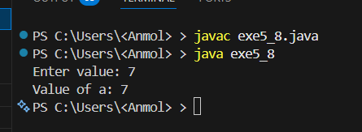
Observation: When the object of the Constructor class is created, the constructor is called, which in turn calls the instance method readValue(). The readValue() method prompts the user to enter a value, reads it from the console, and adds it to the instance variable 'a'. Finally, the value of 'a' is displayed in the main method.

Exe5_9
// Create a class with no constructor and one instance variable.
// Create object and print variable value.
// Then define your own constructor.
// Observe difference and explain default constructor role.
class nocon
{
int a;
// nocon(int x)
// {
// a=x;
// }
}
class exe5_9
{
public static void main(String args[])
{
nocon obj=new nocon();
System.out.println("Value of a: "+obj.a);
// nocon obj1=new nocon(17);
// System.out.println("Value of a: "+obj1.a);
System.out.println("In this program if we comment in the comment out part of both the class and main method then the default constructor will be called and the value of a will be 0 because it is an instance variable and it is initialized to 0 by default. But if we uncomment the comment out part then the default constructor will not be called and the value of a will be 17 because we have defined our own constructor which takes an integer argument and assigns it to a.");
}
}
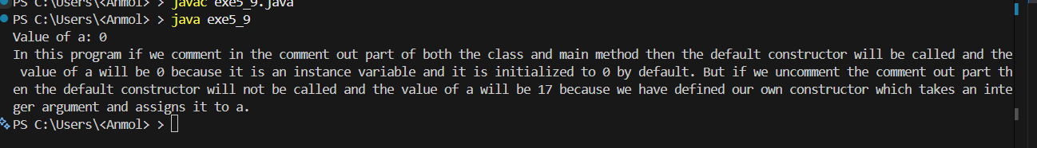
Observation: In this program, if we comment out the constructor in the nocon class and the corresponding object creation in the main method, the default constructor will be called when we create an object of the nocon class. The instance variable 'a' will be initialized to its default value, which is 0 for integers. However, if we uncomment the constructor and create an object using it, the default constructor will not be called, and instead, our defined constructor will be executed, assigning the value 17 to 'a'. This demonstrates that when a user-defined constructor is present, the default constructor is not automatically provided by the compiler.

Exe5_10
// Create a class Student with name, roll number and static variable totalStudents.
// Overload constructors (default and parameterized).
// Each time object is created, increment totalStudents.
// Display total number of students created.
class Student
{
String name;
int rollno;
static int totalStudents;
Student()
{
totalStudents++;
}
Student(String name, int rollno)
{
this.name=name;
this.rollno=rollno;
totalStudents++;
}
}
public class exe5_10
{
public static void main(String args[])
{
Student s1=new Student();
Student s2=new Student("Alice", 1);
Student s3=new Student("Bob", 2);
System.out.println("Total students created: "+Student.totalStudents);
}
}
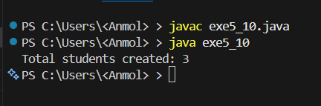
Observation: In this program, we have a Student class with two constructors: a default constructor and a parameterized constructor. Each time an object of the Student class is created, the static variable totalStudents is incremented. In the main method, we create three Student objects, which results in totalStudents being incremented three times. Finally, we display the total number of students created, which will output "Total students created: 3".

Exe5_11
// Create a class to overload method area() for circle, rectangle, and triangle.
import java.util.*;
class Area
{
double area(double r)
{
return 3.14*r*r;
}
double area(double l,double b)
{
return l*b;
}
double area(double a,double b,double c)
{
double s=(a+b+c)/2;
return Math.sqrt(s*(s-a)*(s-b)*(s-c));
}
}
public class exe5_11
{
public static void main(String args[])
{
Scanner sc=new Scanner(System.in);
Area obj=new Area();
System.out.println("Enter radius of circle: ");
double r=sc.nextDouble();
System.out.println("Area of circle: "+obj.area(r));
System.out.println("Enter length and breadth of rectangle: ");
double l=sc.nextDouble();
double b=sc.nextDouble();
System.out.println("Area of rectangle: "+obj.area(l,b));
System.out.println("Enter sides of triangle: ");
double x=sc.nextDouble();
double y=sc.nextDouble();
double z=sc.nextDouble();
System.out.println("Area of triangle: "+obj.area(x,y,z));
}
}
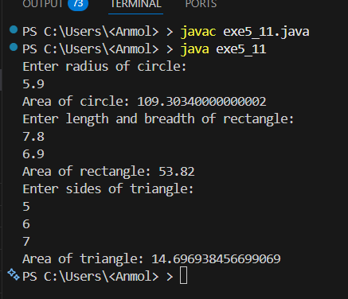
Observation: The program defines a class Area with three overloaded methods named area() to calculate the area of a circle, rectangle, and triangle. The main method prompts the user to input the necessary dimensions for each shape, calls the appropriate area() method based on the input, and displays the calculated area for each shape.

Exe5_12
// Implement constructor overloading in a Student class.

class student
{
String name;
int roll;
student()
{
name="Rahul";
roll=35;
}
student(String name,int roll)
{
this.name=name;
this.roll=roll;
}
}
public class exe5_12
{
public static void main(String args[])
{
student s1=new student();
student s2=new student("Anmol", 17);
System.out.println("Student 1: Name="+s1.name+",Roll="+s1.roll);
System.out.println("Student 2: Name="+s2.name+",Roll="+s2.roll);
}
}

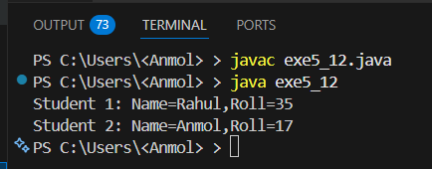
Observation: The program demonstrates constructor overloading in the Student class. The default constructor initializes the name and roll number with fixed values, while the parameterized constructor allows for user-provided values. In the main method, we create two Student objects using both constructors and display their details.

Exe5_13
// Overload a method to calculate volume of cube and cylinder.
import java.util.*;
class Volume
{
double volume(double a)
{
return a*a*a;
}
double volume(double r,double h)
{
return 3.14*r*r*h;
}
}
public class exe5_13
{
public static void main(String args[])
{
Scanner sc=new Scanner(System.in);
Volume obj=new Volume();
System.out.println("Enter side of cube: ");
double a=sc.nextDouble();
System.out.println("Volume of cube: "+obj.volume(a));
System.out.println("Enter radius and height of cylinder: ");
double r=sc.nextDouble();
double h=sc.nextDouble();
System.out.println("Volume of cylinder: "+obj.volume(r,h));
}
}
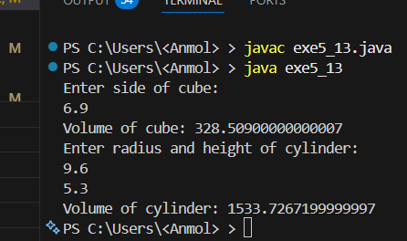
Observation: The program defines a class Volume with two overloaded methods named volume() to calculate the volume of a cube and a cylinder. The main method prompts the user to input the necessary dimensions for each shape, calls the appropriate volume() method based on the input, and displays the calculated volume for each shape.

Exe5_14
// Create a class demonstrating method overloading using different data types.
class Overloading
{
void display(int a)
{
System.out.println("Integer: "+a);
}
void display(double b)
{
System.out.println("Double: "+b);
}
void display(String c)
{
System.out.println("String: "+c);
}
}
public class exe5_14
{
public static void main(String args[])
{
Overloading obj=new Overloading();
obj.display(17);
obj.display(3.14);
obj.display("Hello");
}
}
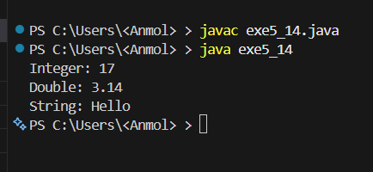
Observation: The program defines a class Overloading with three overloaded methods named display() that accept different data types: int, double, and String. In the main method, we create an instance of the Overloading class and call the display() method with different types of arguments (an integer, a double, and a string). The appropriate overloaded method is called based on the type of argument passed, demonstrating method overloading in Java.

Exe5_15
// Write a program showing constructor chaining.
class Student
{
String name;
int rollno;
Student()
{
this("Rahul",35);
}
Student(String name,int rollno)
{
this.name=name;
this.rollno=rollno;
}
}
public class exe5_15
{
public static void main(String args[])
{
Student s1=new Student();
Student s2=new Student("Anmol",37);
System.out.println("Student 1: Name="+s1.name+",Roll="+s1.rollno);
System.out.println("Student 2: Name="+s2.name+",Roll="+s2.rollno);
}
}
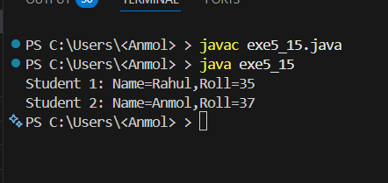
Observation: The program demonstrates constructor chaining in the Student class. The default constructor calls the parameterized constructor using the 'this' keyword, passing fixed values for name and roll number. When we create an object using the default constructor, it initializes the name and roll number with the values specified in the parameterized constructor. When we create an object using the parameterized constructor, it initializes the name and roll number with the user-provided values. Finally, we display the details of both students to verify that the constructor chaining works as expected.

